Ssn : A86904824001
Name : Thrisha M
C++ Assignment

- //Progarm to print fibonoic series with out function
#include<iostream>
using namespace std;
int main()
{
int n=5,a=0,b=1,next;
cout<<"enter the fibnoic series: ";
for(int i=1;i<=n;++i)
{
cout<<a;
next=a+b;
b=next;
}
return 0;
}

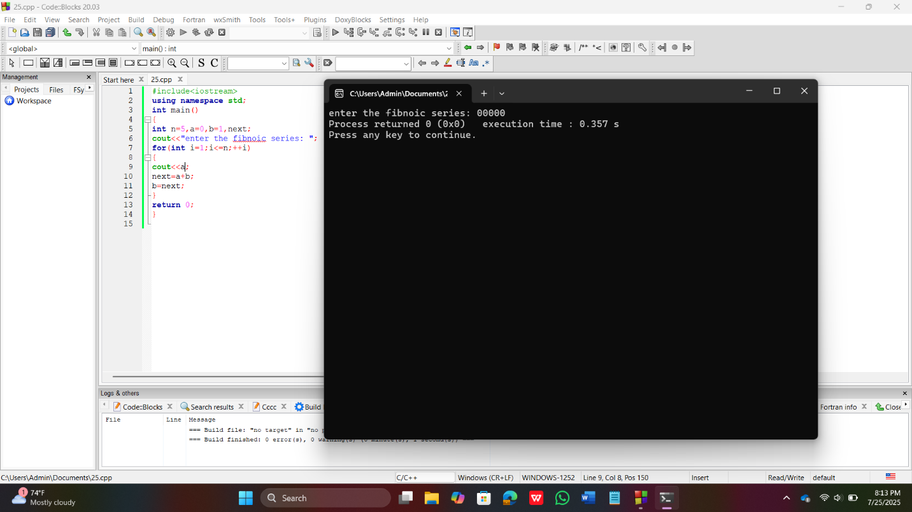

- //Progarm to print fibonoic series with using function
#include<iostream>
using namespace std;
void printfibonacciseries(int n)
{
int a=0,b=1,next;
cout<<"Fibnoic series of"<<n<<"number is: "<<endl;
for(int i=1;i<=n;i++)
{
cout<<a;
next=a+b;
a=b;
b=next;
}
cout<<endl;
}
int main()
{
int num;
cout<<"enter the number of terms for the finbanacci series: ";
cin>>num;
printfibonacciseries(num);
return 0;
}

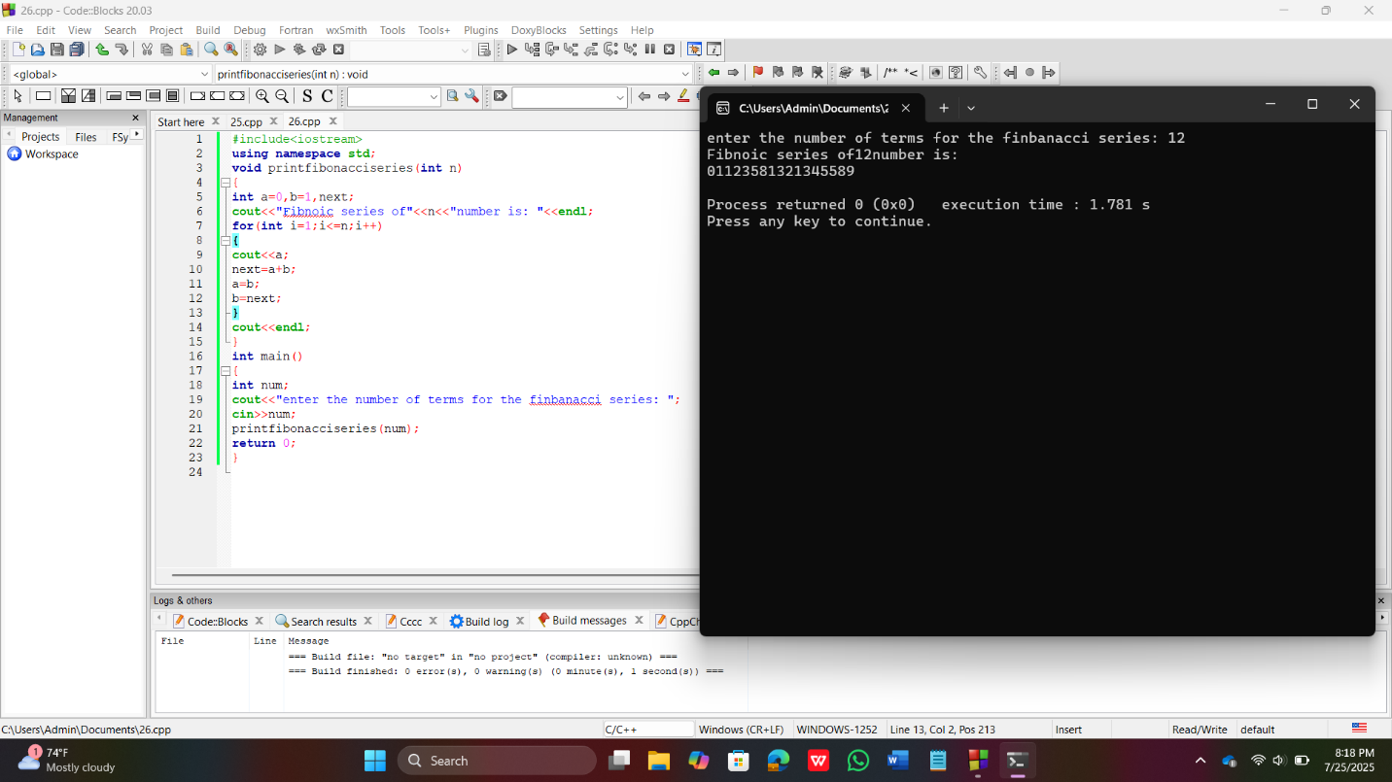

- //Program for prime number
#include<iostream>
using namespace std;
int main()
{
int num;
cout<<" enter a positive integer: ";
cin>>num;
for(int i=2;i<num;i++)
{
if(num%1==0)
{
cout<<num<<" is not a prime number."<<endl;
return 0;
}
cout<<num<<" is a prime number.";
}
return 0;
}

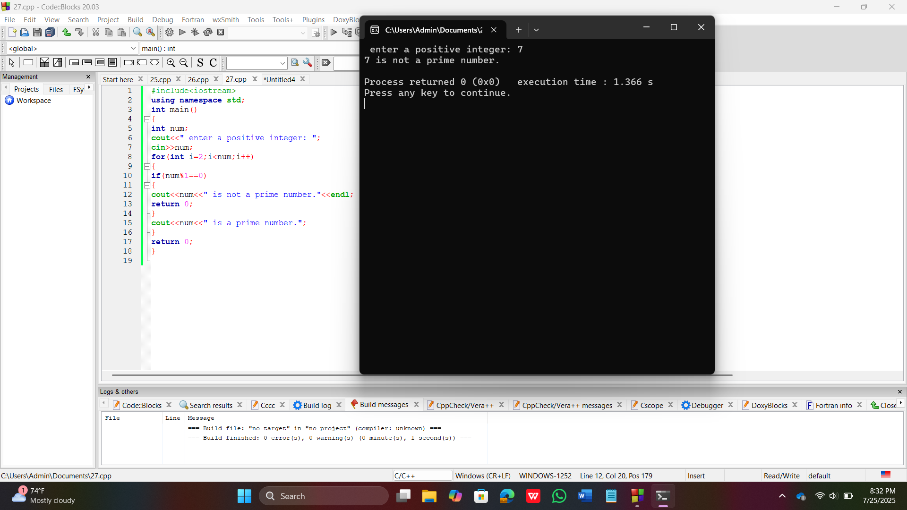

- //Program for print prime number
#include<iostream>
using namespace std;
int main()
{
int num,flag=0;
cout<<" enter a positive integer: ";
cin>>num;
for(int i=2;i<num;i++)
{
if(num%1==0)
{
flag=1;
break;
}
}
if(flag==1)
{
cout<<num<<" is not a prime number."<<endl;
}
else
{
cout<<num<<" is a prime number.";
}
return 0;
}

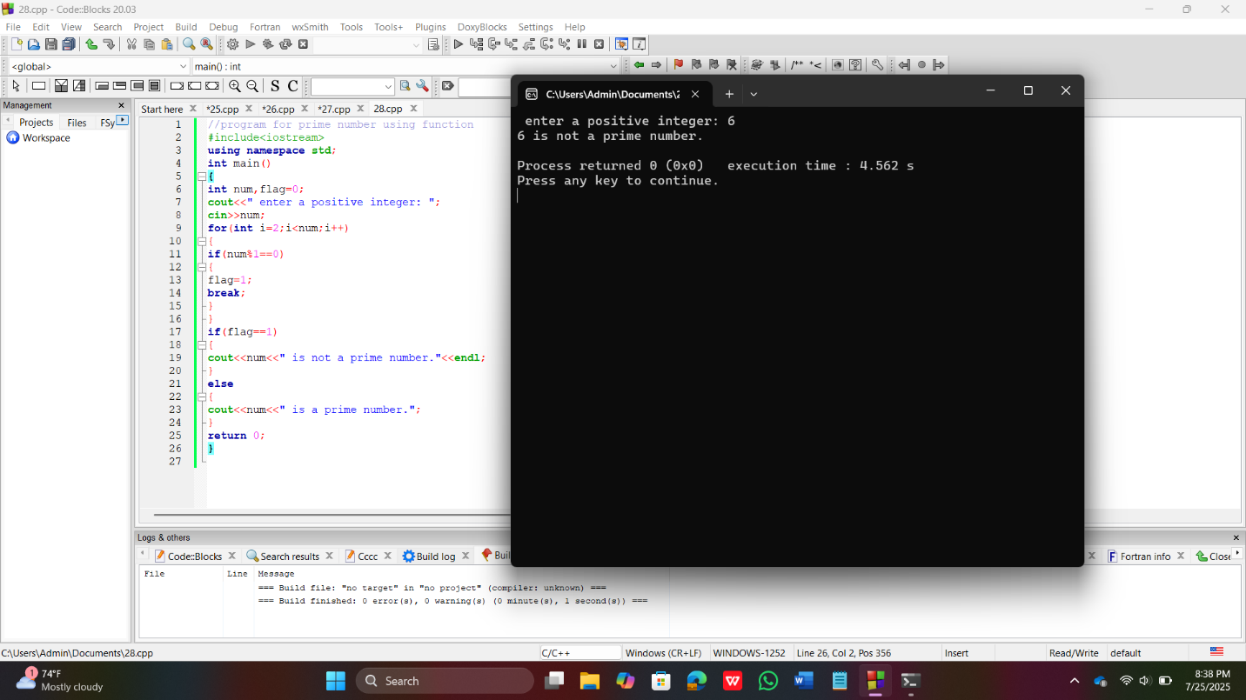

- //Program to print mid number from start to end
#include<iostream>
using namespace std;
int main()
{
int start,end,i;
cout<<"enter the starting number";
cin>>start;
cout<<"enter the ending number";
cin>>end;
for(int i=start;i<=end;i++)
{
int flag=0;
for(int j=2;j<i;j++)
{
if(i%2==0)
{
flag=1;
break;
}
}
if(flag==0)
{
cout<<i<<endl;
}
}
return 0;
}

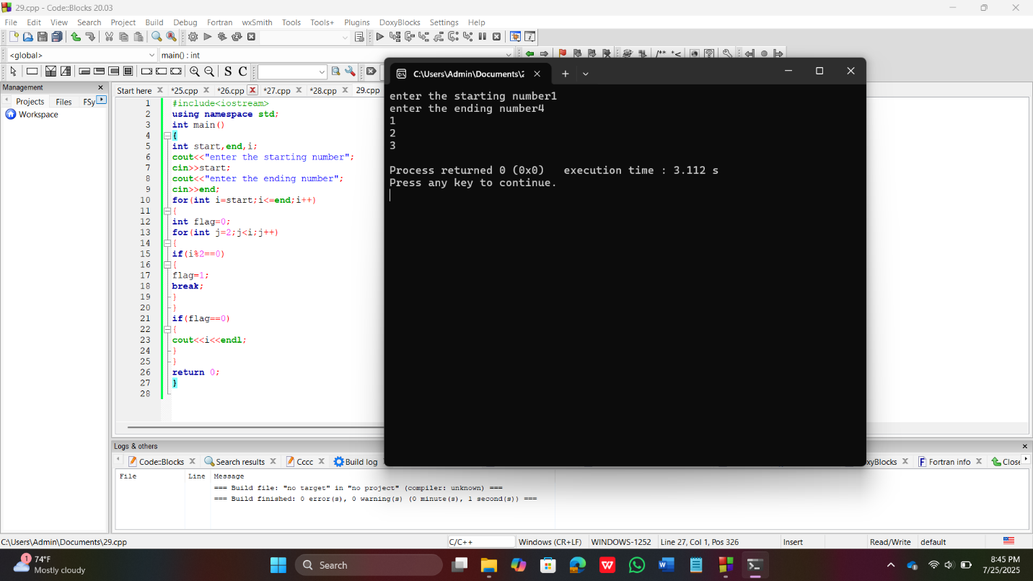

- //Printing prime number from starting number to ending number
#include<iostream>
using namespace std;
int main()
{
int start,end,i;
cout<<"enter the starting number";
cin>>start;
cout<<"enter the ending number";
cin>>end;
cout<<"the prime number between start and end"<<endl;
for(int i=start;i<=end;i++)
{
int flag=0;
for(int j=2;j<i;j++)
{
if(i%2==0)
{
flag=1;
break;
}
}
if(flag==0)
{
cout<<i<<endl;
}
}
return 0;
}

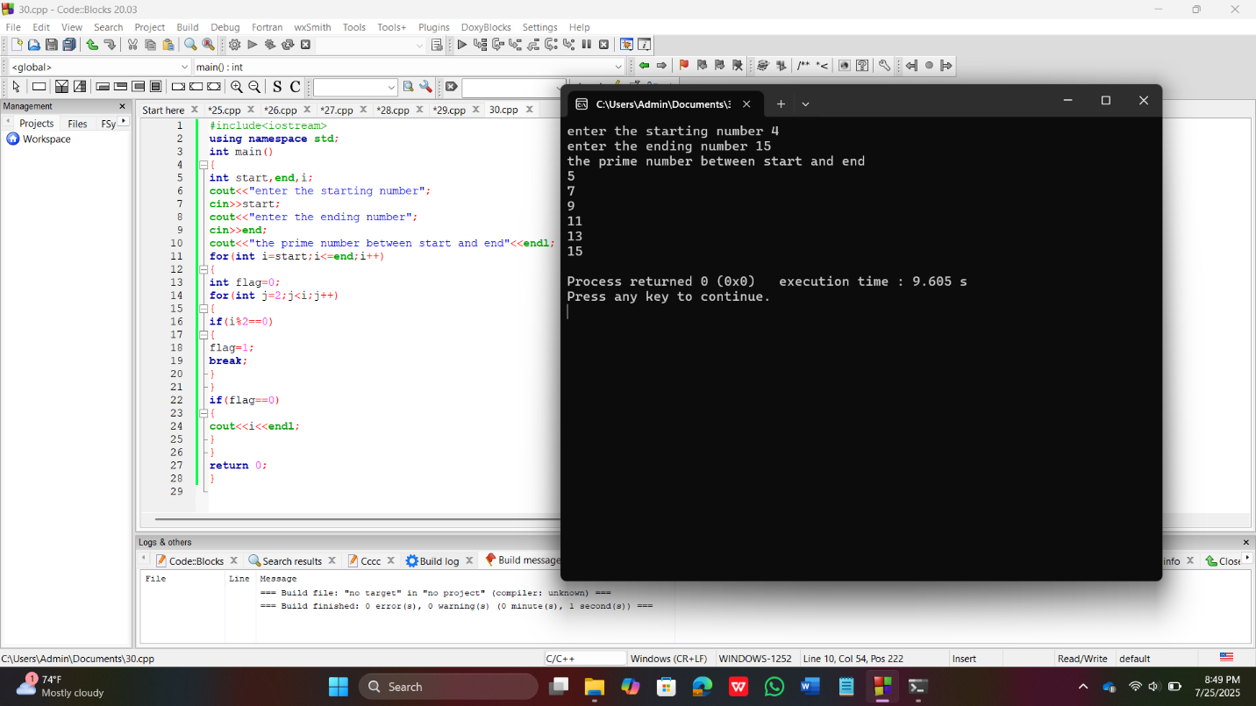

- //Program to print all even number between a range of numbers
#include<iostream>
using namespace std;
int main()
{
int start,end,i;
cout<<"enter the starting number ";
cin>>start;
cout<<"enter the ending number ";
cin>>end;
cout<<"the all even numbers between the given range "<<endl;
for(int i=start;i<=end;i++)
if(i%2==0)
{
cout<<i<<endl;
}
return 0;
}

